PROJECT REPORT
Title: AI-Based Farmer Query Prioritization System for Smart Agricultural Advisory Services
--Subodh Kushwaha
(2026)

Index

- Introduction and Motivation
- Problem Statement
- Dataset Understanding
- Methodology
- Implementation Details
- Results and Discussions
- Conclusion
- References

Appendix

1.Introduction and Motivation
Agriculture is one of the most important sectors of the Indian economy, supporting the livelihoods of millions of farmers. Modern farming faces numerous challenges, including pest attacks, crop diseases, nutrient deficiencies, unpredictable weather conditions, irrigation management, and market fluctuations. Farmers frequently seek expert guidance through agricultural advisory services, helplines, and online platforms. As the number of farmer queries continues to grow, manually reviewing and responding to every query becomes time-consuming and may delay assistance to farmers facing critical situations.
Artificial Intelligence (AI) provides an effective solution for improving agricultural advisory systems by automatically analyzing large volumes of textual farmer queries. Natural Language Processing (NLP), a branch of AI, enables computers to understand, process, and classify text-based information. By leveraging NLP and machine learning techniques, farmer queries can be analyzed automatically and prioritized based on their urgency.
The objective of this project is to develop an AI-Based Farmer Query Prioritization System that classifies farmer queries into three priority levels: High, Medium, and Low. Queries related to diseases, pest attacks, or sudden crop damage are assigned high priority, while routine cultivation practices receive medium priority and informational queries regarding government schemes, loans, or market prices are categorized as low priority. This prioritization helps agricultural experts respond more efficiently by ensuring that urgent issues receive immediate attention.
A real-world dataset containing 178,939 farmer queries and expert responses was used for this project. Since the dataset did not contain priority labels, a rule-based annotation strategy was developed to generate priority categories using agriculture-specific keywords. The annotated dataset was then used to train multiple machine learning models, including Naïve Bayes, Logistic Regression, and Linear Support Vector Machine (Linear SVM). Experimental evaluation demonstrated that the Linear SVM model achieved the highest classification accuracy, making it the most suitable model for this application.
This project demonstrates how AI can support agricultural decision-making by reducing response time, improving advisory efficiency, and assisting experts in handling large volumes of farmer queries. The proposed system highlights the practical application of Artificial Intelligence and Natural Language Processing in building scalable and intelligent agricultural support systems.

Workflow diagram
Farmer Query
│
▼
AI-Based Priority Classification
│
▼
High / Medium / Low Priority
│
▼
Agricultural Expert Response

2.Problem Statement
Agricultural advisory services receive a large number of queries from farmers seeking guidance on crop diseases, pest infestations, irrigation practices, fertilizer recommendations, government schemes, and market-related information. As the volume of these queries increases, manually reviewing and prioritizing each query becomes a challenging and time-consuming task. This can result in delays in responding to critical issues, particularly those involving severe crop diseases or pest attacks, where timely intervention is essential to minimize crop losses.
Most existing advisory systems focus on providing responses but do not automatically determine the urgency of incoming farmer queries. Consequently, urgent and non-urgent queries are often processed in the same order, reducing the overall efficiency of agricultural support services.
To address this challenge, this project proposes an AI-Based Farmer Query Prioritization System that automatically analyzes the textual content of farmer queries and classifies them into three priority levels:
- High Priority: Queries related to crop diseases, pest attacks, infections, or situations requiring immediate attention.
- Medium Priority: Queries regarding cultivation practices, irrigation, fertilizer application, seed selection, and crop management.
- Low Priority: General informational queries related to government schemes, subsidies, loans, insurance, and market prices.
The proposed system employs Natural Language Processing (NLP) techniques for text preprocessing and TF-IDF (Term Frequency–Inverse Document Frequency) for feature extraction. Multiple supervised machine learning algorithms, including Naïve Bayes, Logistic Regression, and Linear Support Vector Machine (Linear SVM), are trained and evaluated to identify the most effective model for priority classification.
The primary objective of this project is to develop an intelligent and scalable AI system capable of automatically prioritizing farmer queries, enabling agricultural experts to respond more efficiently to urgent issues while improving the overall effectiveness of agricultural advisory services.

Objectives of the Project
The specific objectives of this project are:
- To analyze a real-world dataset of farmer queries and expert responses.
- To preprocess and clean textual agricultural data for machine learning.
- To generate priority labels (High, Medium, and Low) using a rule-based annotation strategy.
- To convert textual queries into numerical features using TF-IDF vectorization.
- To train and compare multiple supervised machine learning models for priority classification.
- To evaluate the models using performance metrics such as Accuracy, Precision, Recall, F1-Score, and Confusion Matrix.
- To develop an AI-based system capable of predicting the priority of unseen farmer queries with high accuracy.

Workflow diagram:
Farmer Query
│
▼
Text Preprocessing (NLP)
│
▼
TF-IDF Feature Extraction
│
▼
Machine Learning Classification
│
▼
High / Medium / Low Priority
│
▼
Faster Agricultural Expert Response

3. Dataset Understanding
3.1 Dataset Overview
A real-world agricultural query dataset was used in this project. The dataset consists of farmer questions and the corresponding responses provided by agricultural experts. It represents practical problems faced by farmers in their daily agricultural activities, including crop diseases, pest attacks, fertilizer recommendations, irrigation practices, government schemes, and market-related information.
The dataset was selected because it contains authentic agricultural queries, making it suitable for developing an AI-based farmer query prioritization system.

3.2 Dataset Source
Dataset Name: Farmer Questions and Answers Dataset
Source: Kaggle (Agricultural Farmer Query Dataset)
File Used: questionsv4.csv
 | questions | answers | query_length | word_count | Priority
0 | asking about the control measure for aphid inf... | suggested him to spray rogor@2ml/lit.at evenin... | 71 | 11 | High
1 | asking about the control measure of flower dro... | suggested him to apply fertilizer in recommend... | 76 | 13 | Medium
2 | asking about how to avail kisan credit card lo... | suggested to consult with officer-marketing an... | 63 | 12 | Low
3 | asking about source of early ahu rice variety | suggested to take early ahu rice variety from ... | 45 | 8 | Medium
4 | asking that he has not got proper fruit from h... | suggested him to aplly recommended fertilizer ... | 62 | 12 | Medium

3.3 Dataset Description
The dataset contains 178,939 records and 2 primary attributes.
Attribute | Description
questions | Farmer's question submitted to the agricultural advisory system
answers | Expert response provided for the corresponding farmer query
During preprocessing, three additional attributes were created for this project.
New Attribute | Description
query_length | Number of characters in each farmer query
Intent | Agricultural category assigned using rule-based keyword matching
Priority | High, Medium, or Low priority generated using rule-based annotation.
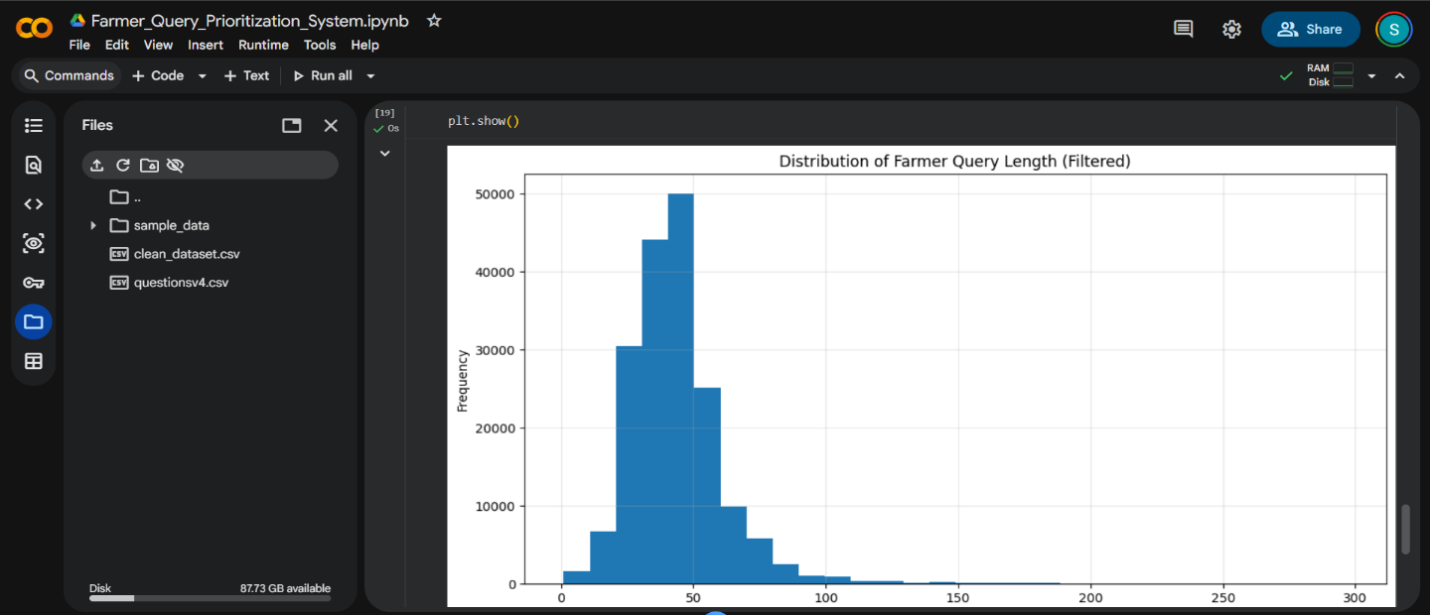
Figure 3.3: Histogram of Farmer Query Length

3.4 Data Exploration
The dataset was initially explored to understand its structure and quality.
The following preprocessing steps were performed:
- Imported the dataset into Google Colab using the Pandas library.
- Examined the dataset structure using df.info().
- Verified the total number of records and attributes.
- Checked for missing values.
- Examined duplicate records.
- Calculated the length of each farmer query.
- Generated statistical summaries and visualizations.
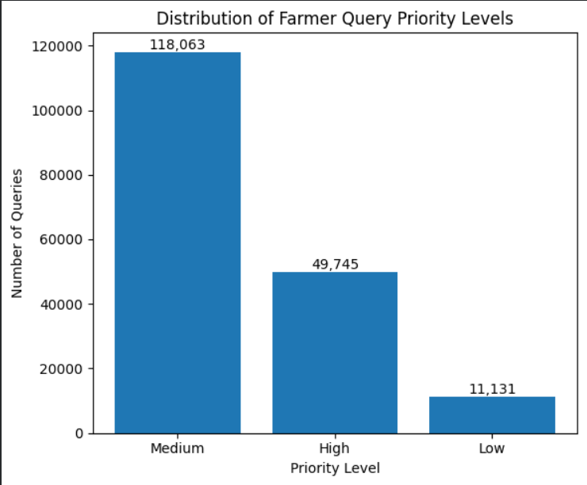
Figure 3.4: Priority Distribution Bar Chart

3.5 Data Preprocessing
Before training the machine learning models, several preprocessing operations were performed:
- Converted text to lowercase.
- Removed unnecessary spaces and punctuation where required.
- Generated the query_length feature.
- Created an Intent column using keyword-based classification.
- Generated Priority labels (High, Medium, and Low) using a rule-based annotation strategy.
- Saved the processed dataset for model training.

3.6 Priority Distribution
After annotation, the dataset was distributed as follows:
Priority | Number of Queries
Medium | 128,688
High | 43,617
Low | 6,634
This distribution indicates that most farmer queries relate to routine agricultural advisory topics, while a smaller portion corresponds to urgent situations such as diseases and pest attacks.

3.7 Exploratory Data Analysis (EDA)
Several exploratory analyses were carried out to understand the characteristics of the dataset.
These included:
- Dataset information
- Missing value analysis
- Duplicate record analysis
- Query length analysis
- Distribution of farmer query lengths
- Priority distribution analysis
The histogram of farmer query lengths showed that the majority of queries were relatively short, while a few unusually long queries acted as outliers. Such exploratory analysis provided useful insights into the nature of the dataset and supported the preprocessing decisions made before model training.

4. Methodology
The proposed AI-based Farmer Query Prioritization System follows a supervised machine learning approach for classifying farmer queries into High, Medium, and Low priority levels. The overall methodology consists of the following steps:
- Data Collection: A real-world dataset containing farmer queries and expert responses was collected and imported into Google Colab.
- Data Preprocessing: The dataset was cleaned, duplicate records were checked, and query length features were generated. Rule-based annotation was used to assign Intent and Priority labels to each query.
- Feature Extraction: The textual farmer queries were converted into numerical feature vectors using the TF-IDF (Term Frequency–Inverse Document Frequency) vectorization technique.
- Model Training: The dataset was divided into training (80%) and testing (20%) sets. Three supervised machine learning algorithms were trained and evaluated:
  - Naïve Bayes
  - Logistic Regression
  - Linear Support Vector Machine (Linear SVM)
- Model Evaluation: The trained models were compared using Accuracy, Precision, Recall, F1-Score, and Confusion Matrix. The model with the highest accuracy was selected as the final classifier.
- Prediction: The final model predicts the priority level of a new farmer query, enabling agricultural experts to identify urgent cases quickly.

Figure 4.1: Methodology Workflow
Farmer Query
│
▼
Data Preprocessing
│
▼
Rule-Based Labeling
(Intent & Priority)
│
▼
TF-IDF Vectorization
│
▼
Train/Test Split (80:20)
│
▼
Naïve Bayes | Logistic Regression | Linear SVM
│
▼
Model Evaluation
│
▼
Priority Prediction (High/Medium/Low)

5. Implementation Details
The proposed system was implemented using Google Colab and Python. The farmer query dataset was loaded using the Pandas library and preprocessed to prepare it for machine learning. Two additional attributes, Intent and Priority, were generated using a rule-based keyword annotation approach.
The textual queries were transformed into numerical feature vectors using the TF-IDF (Term Frequency–Inverse Document Frequency) vectorizer. The dataset was then divided into 80% training and 20% testing sets using the train_test_split() function from Scikit-learn.
Three supervised machine learning algorithms were implemented and compared:
- Naïve Bayes
- Logistic Regression
- Linear Support Vector Machine (Linear SVM)
The trained models were evaluated using Accuracy, Precision, Recall, F1-Score, and Confusion Matrix. Among all the models, Linear SVM achieved the highest classification accuracy and was selected as the final model.
Finally, a prediction function was developed to classify new farmer queries into High, Medium, or Low priority, enabling quick identification of urgent agricultural issues.

Tools and Technologies Used
Tool/Library | Purpose
Google Colab | Development environment
Python | Programming language
Pandas | Data loading and preprocessing
NumPy | Numerical operations
Scikit-learn | Machine learning algorithms and evaluation
TF-IDF Vectorizer | Text feature extraction
Matplotlib | Data visualization

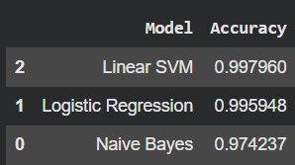
Figure 5 : Screenshot of the model comparison table (the accuracy table)

6. Results and Discussion
The performance of the proposed Farmer Query Prioritization System was evaluated using three supervised machine learning algorithms: Naïve Bayes, Logistic Regression, and Linear Support Vector Machine (Linear SVM). The models were trained using TF-IDF features extracted from farmer queries and tested on 20% of the dataset.
Among the three models, Linear SVM achieved the highest classification accuracy of 99.80%, outperforming Logistic Regression (99.59%) and Naïve Bayes (97.42%). Based on these results, Linear SVM was selected as the final model for farmer query priority prediction.
Model Performance
Model | Accuracy
Naïve Bayes | 97.42%
Logistic Regression | 99.59%
Linear SVM | 99.80%

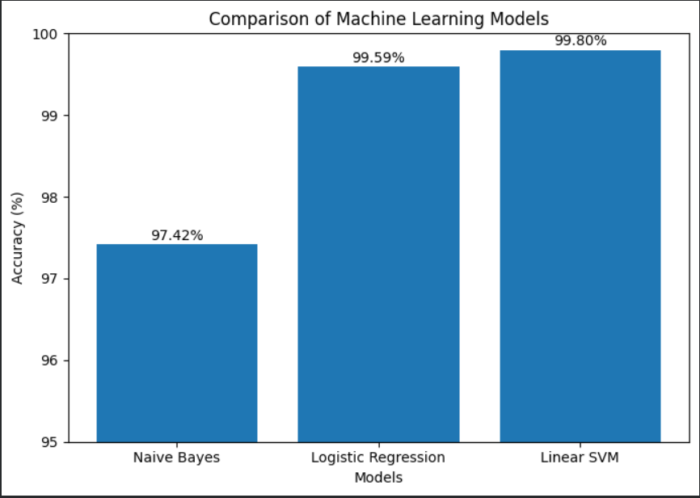
Figure 6.1: Comparison of Machine Learning Models (Accuracy Table or Bar Chart)

The classification report of the Linear SVM model showed excellent performance across all three priority classes. The model achieved precision, recall, and F1-score values close to 1.00, indicating that it was able to classify farmer queries with very high consistency.
The confusion matrix further confirmed the effectiveness of the proposed approach. Most farmer queries were correctly classified into their respective priority levels, while only a small number of queries were misclassified. This demonstrates that the combination of TF-IDF feature extraction and the Linear SVM classifier is highly effective for agricultural text classification.
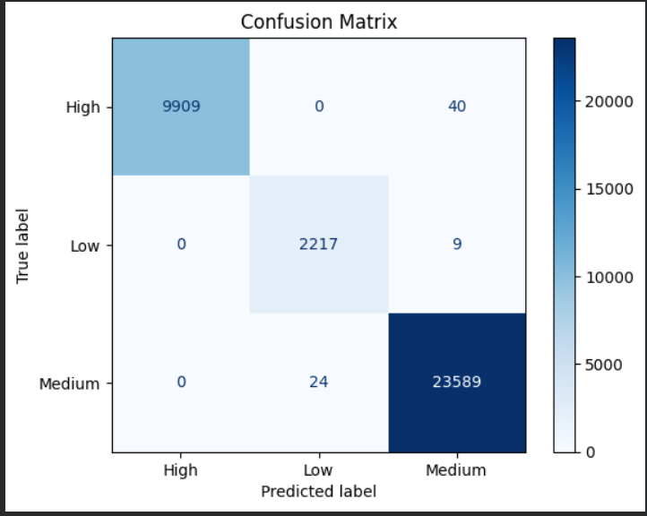
Figure 6.2: Confusion matrix
The developed prediction system was also tested using custom farmer queries. The model successfully assigned appropriate priority levels, demonstrating its capability to assist agricultural advisory services in identifying urgent farmer issues quickly.
Although the proposed system achieved excellent performance, the priority labels were generated using a rule-based annotation strategy because the original dataset did not contain urgency labels. Therefore, the reported accuracy reflects the model's ability to learn these annotated priority patterns. Future work can improve the system by using manually annotated datasets and integrating advanced deep learning or transformer-based language models for more robust priority prediction.
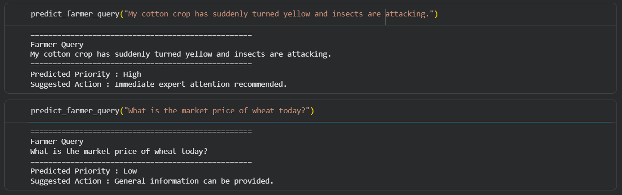
Figure 6.3: Sample Predictions

7.Conclusions
This project successfully developed an AI-Based Farmer Query Prioritization System to assist agricultural advisory services in identifying and prioritizing farmer queries based on their urgency. A real-world dataset containing farmer queries and expert responses was collected, analyzed, and preprocessed. Since the original dataset did not contain priority labels, a rule-based annotation approach was adopted to classify the queries into High, Medium, and Low priority categories.
The preprocessed textual data was transformed into numerical features using the TF-IDF vectorization technique, and three supervised machine learning algorithms—Naïve Bayes, Logistic Regression, and Linear Support Vector Machine (Linear SVM)—were trained and evaluated. Experimental results showed that the Linear SVM model achieved the highest classification accuracy of 99.80%, making it the most suitable model for this task.
The proposed system demonstrates how Artificial Intelligence and Natural Language Processing can improve agricultural advisory services by automatically identifying urgent farmer queries and helping experts respond more efficiently. Such a system can reduce response time, improve resource utilization, and support faster decision-making in real-world agricultural environments.
Although the current system performs effectively, future enhancements can include the use of manually annotated datasets, multilingual farmer queries, and advanced deep learning or transformer-based language models. These improvements can further increase the robustness and applicability of the system in large-scale agricultural advisory platforms.

8. References
[1] Kaggle, Farmer Questions and Answers Dataset. Available: https://www.kaggle.com/
[2] F. Pedregosa et al., "Scikit-learn: Machine Learning in Python," Journal of Machine Learning Research, vol. 12, pp. 2825–2830, 2011.
[3] J. Ramos, "Using TF-IDF to Determine Word Relevance in Document Queries," Proceedings of the First Instructional Conference on Machine Learning, 2003.
[4] T. Joachims, Text Categorization with Support Vector Machines: Learning with Many Relevant Features, Springer, 1998.
[5] Python Software Foundation, Python Programming Language. Available: https://www.python.org/
[6] Google, Google Colaboratory. Available: https://colab.research.google.com/
[7] F. Chollet et al., Scikit-learn Documentation. Available: https://scikit-learn.org/
[8] McKinney, W., Python for Data Analysis, 3rd ed., O'Reilly Media, 2022.

Appendix
Appendix A: Sample Dataset
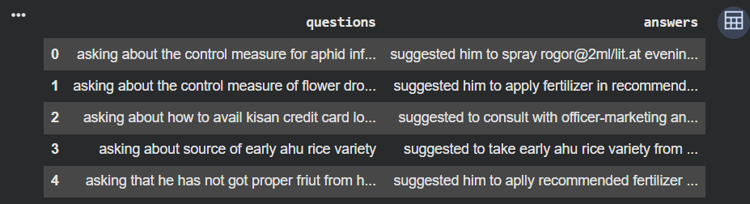
Figure : Screenshot of df.head()
Appendix E: Key Code Snippets
Include only the important parts:
- TF-IDF Vectorization
# Convert text data into numerical features
vectorizer = TfidfVectorizer(
stop_words='english',
max_features=5000
)

X_train_tfidf = vectorizer.fit_transform(X_train)
X_test_tfidf = vectorizer.transform(X_test)
- Model Training (Linear SVM)
- Prediction Function
def predict_priority(query):
# Convert input query into TF-IDF features
query_vector = vectorizer.transform([query])

# Predict priority using the trained Linear SVM model
prediction = svm.predict(query_vector)

return prediction[0]

# Example Usage
query = "My tomato crop has suddenly dried after heavy rain."
print("Farmer Query:", query)
print("Predicted Priority:", predict_priority(query))

------------------------------------------------------------------------------------

